Simulated Video Experiments of
Generalized Uncertainty Principle

Zeng jia ning
Introduction:
The author is not a physical theory expert, but a worker who is engaged in the work of motion system and instrument sensor. Please distinguish the content by yourself.
This experiment comes from the unexpected discovery. At the same time, its principle is simple enough. It shows the sources of uncertainty and random effects from a quantized and controllable process. The direct explanation of it can be copied and extended to other similar phenomena. I chose to explain it first because it's the next lead on another computational model experiment.
This visual experiment was originally created to show the vision of random signals/cellular automata, and was altered after the effect was discovered.
This experiment may help us better understand the sources of uncertainty. Cancel some unreliable guesses.
Although some probabilistic formulas are used, this experiment explains the source of nonlinearity effect, which reveals the nature of reality more inclined to determinism.
Unless we can strictly simulate and compare all the behaviors of a micro particle, otherwise,
It can't be completely equivalent to the behavior of microscopic particles.
The simulation experiment here is conducted on the principle of generalized uncertainty.
It can also help to understand the effects of uncertainty principles in other areas.
In this experiment, the "observer effect" is interpreted as the synthetically effect of jitter between multiple coupling layers.
Experiments show the observed deviations that can be caused by ubiquitous small error jitter, whichever coupling interface these errors come from, they cause discrete observations of continuous controllable systems.
It is a simple simulation as far as possible. Its random beat is not artificially designed. 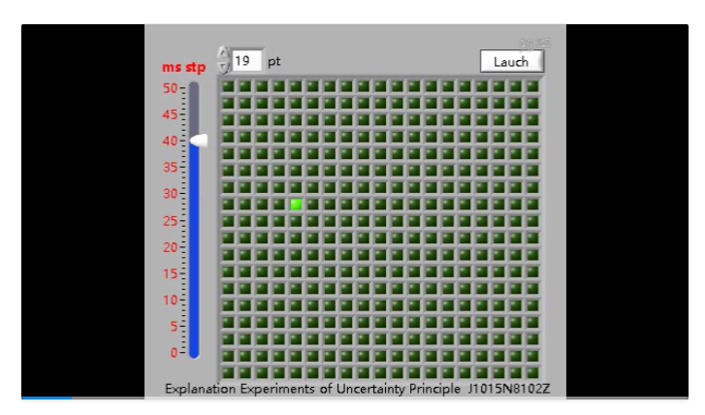

Video1 The original video can be found here
Or https://github.com/noya2012/unc_exp/blob/master/2019-08-29%2018-51-22-sigmat.avi
It shows how errors occur in a fully controllable system, and the effect increases with the control process, thus affecting the observation of the system, making the continuously controllable system seem discrete.

We can ideally and accurately know the position of the light spot in the algorithm, but in fact it is impossible to get the position of the light spot by precise measurement.
This is the demonstration purpose of this explanation video experiment.
Regard on the controllable properties of the system and the relationship between errors gives us a deep understanding of the principle of uncertainty.

After explaining the origin of the experiment (Display refresh of single matrix),
Now we will publish the display matrix experiment described in the original article and you can also find the additional video appendix. [3]

.In the first video, you can see that the green light points are scanned from top to bottom and from left to right.
.Please notes that the slider on the left will gradually adjust the time interval between the appearance of green spots and the advance.
.With the acceleration of the speed of light spot, our observation system has a random number of missing frames relative to the signal source.
.This video is a direct acquisition of desktop drawing, so there must be a sampling interval, the difference between the completion of the drawing and the time difference between the completions of the drawing to the screenshot.
.Close to the end of the video shows the trend of light point to random and disorderly movement. Finally, the light spot appears to be moving in disorder.

That is it, it’s just an experiment done by an ordinary computer.
(Running on a computer with enough high frequencies, Light spots will appear randomly without direction.)

There are 4 main steps in facular recording from signal generation to video acquisition. Through another simulation experiment, the source of error is known:
1. There is a certain error in the system clock, which is called [a] error.
2. There is a time difference in screen image processing, which is called [b] error.
3. Software video capture or human eye vision also has time difference, which is called [c]error.
4. There are always unknown interference factors or hidden variables. This is called [d] error.
You can also add the observer's interference variables to the system.
To reproduce another type of experiment, the number of variables is not fixed, according to your actual settings.
[a],[b],[c],[d], are the four sampling stages of the nonlinear error matrix , or vector sequence
These error intervals can be visually known or recorded synchronously by more sophisticated instruments. Obviously, they are not equidistant.
In this example, The unsynchronized two or two errors amplify the jitter, It is also the synthetically effect that the coupling of jitter signal and jitter sampling is not synchronized. Intermediate coupling hierarchies are not always recognized.

Simple top-level model
Based on the information we have, consider the following 4 errors
.The global information is [I],
.The cumulative error is[H],
.And the effective information that enters the human eye or observation instrument is [i].
H= (1-a)* (1-b)* (1-c)*(1-d)
i = I * H

That is it

A second careful analysis.
1. Multitask fluctuation of system clock superimposed by software when projecting to screen
2. Time Overlay Multitask Jitter in Software Video Preservation and Drawing
3. sampling rate jitter of human vision Or the sampling jitter of the screen recording.
In order to minimize the principle of variable analysis, the observer's interference with the system was not considered in this experiment.

You can see that the image is totally different each time the whole matrix is refreshed after the speed of light spot is accelerated. So the diagonal features are completely different.

From this experiment, we can realize that the asynchrony caused by clock jitter is the cause of uncertainty.
Through explanation and expansion, we can also intuitively recognize that jitter comes from the underlying layer, and that jitter comes from observing itself, even from the entire environment.

Concurrently, we can get more recurrence from the method and principle for the understanding and interpretation of this natural and profound problem in different fields.
Extend in meaning:
When we observe the green light spot moving at high speed and jumping disorderly in the matrix,
Assuming that the system is not built by ourselves and the error sequence is not recorded, we have a belief problem. For example, we can believe that these error sequences are non-linear. We believe that the light spot motion here is generating random values.
On the contrary,
Predict the cat's route in a limited space and catch it when you know enough multiple coupling information sequences and errors.[2]
But it doesn't have to do with the topic.
We can also see the role of simulating a system in predicting.
Question：
Is it really unpredictable? Or does it have a repeat pattern that is so complex and so long that it seems chaotic?
The combination of dis-harmonic frequencies can produce very complex "beat" frequencies.
By Woody, From England.
Post at https://physicshelpforum.com/threads/an-experiment-demonstrating-the-principle-of-uncertainty.15401/post-45007
Answer：
Consider Occam's razor principle.
In the simulation experiment of the uncertainty principle, the image is 19*19 points in two dimensions, It does not have the complex behavior of the advanced dynamics system, it is a simple two-dimensional system. The light spot flashes and goes out according to the preset fixed interval.
This can be seen in terms of attributes (we can directly distinguish between complexity sizes)

1. This program simply nests two loops and adds coordinates at a fixed time to the 0/1 state where the green point is set. It clears the matrix immediately after each light. The clearing time depends on the instruction arrival and the precision of the computer clock.

2. If we change this experiment into a Cellular Automata, we need several times the lattice image of the former, and we need to add more than two variables (when we add more formulas in the inner cycle to set the direction of the light point, the goal is to change the direction continuously according to a core formula of two variables, it will become a two-dimensional model. Cellular Automata. In this process, it is necessary to store variables at least once, add them more times by computer, consume more memory to memorize different points of light on the matrix, and carry them more.

3. For chaotic systems, it is a set of differential equations with empirical parameters and three variables. This will be an 3d system, Therefore, a high-density point image and a continuous trajectory are needed to show the visual characteristics of the system. Therefore, more computational complexity is needed. The image of chaotic system constructed according to differential equations will cost more computation with exponential multiple than attribute 2. More intensive image space is also needed.

We can see that the Cellular Automata has the attributes of 1 and 2 above, Chaotic systems have 1, 2, 3 or more properties and lattice, but in this experiment it only has attribute 1.
It is a simple simulation as far as possible. Its random beat is not artificially designed.
The sampling rate of our eyes, the error of the system recording, and the error of the internal clock of the computer, all add up to make this orderly light point look chaotic and unpredictable.
So, that's the other Enlightenment on the methodology.

Appendix:
[1] This experimental video is recorded according to the previous article process, and the source is https://zhuanlan.zhihu.com/p/41999136
“Visual Experiments and Another Interpretation of Uncertainty Principle” (Source files are non-English versions It's just an algorithmic explanation, an article without video, maybe will coming soon in English) was first implemented before October 20181015. In fact, it was done a year earlier.
The author uses the pseudo-code to programming， and recorded the interpretation video, which gives the algorithm and the comments, as well as some interpretation.
[2] Extend reading: A Work from other teams
Predict Schrodinger's Cat Jump
Reference Journal Nature DOI: 10.1038/s41586-019-1287-z
Https://www.nature.com/articles/s41586-019-1287-z
[3] In the early stage, the author used to search for random effects and made simulation, restoring the video of signal principle. The left side still refreshes a light spot for the matrix. The program has a signal generating core, which serves as the signal source and provides the left matrix and the right oscilloscope.
Video2 The original video can be found here.

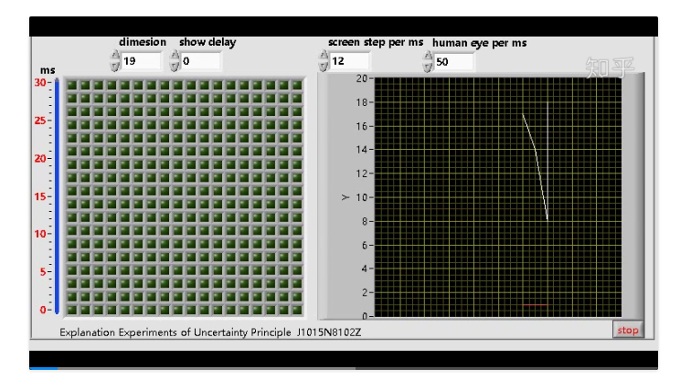
That is to say, on the oscilloscope of the right side of the program, the changing line represents the light point trajectory actually seen by the human eye, and more intuitively represents the source of uncertainty and the clock jitter inherent in the system.

[4] Flow chart used in this experiment program.
Flow chart of the visual experiment program of the principle of uncertainty

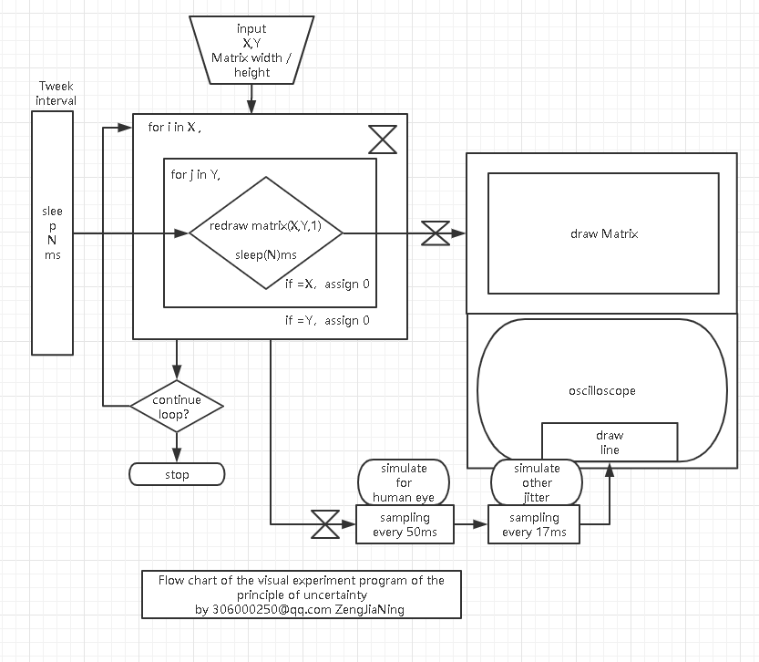
[5] The author is not an expert in physics. Please be careful about the content of the article.
If you find the video useful, you can extract the presentation separately.
Try to keep the information as complete as possible when reprinting the article.
If needs further information or methods to communicate. You can leave a message on the page. Please correct any inaccuracies. Please forgive the bad grammar
Author | Zeng Jia Ning . Engaged in the work of Motion System and Instrument sensor.

